

OPERATION ACTIVE RESOLVE INTELLIGENCE REPORT D+0

# General information

This intelligence report.

VID have divided the area of operations (AOR) in two sectors, and will report on the two sectors, sector NORTH and sector SOUTH.

# Sector NORTH

## 1st Corps

As of 31st august (D+0) 1st Corps is grouped out as follows

1st Corps rear area and HQ ivo Hatay / Hatay airfield (N36 21.000 E036 16.000)

### 10th Armored Division

Located in the valley NORTH of Hatay. Division is spread out in the valley, assessed HQ IVO N36 50.000 E036 33.000. 10th Armored division is reported to have started preperations for an offensive, and is likely preparing for an invasion further NORTH in order to cut of main roads EAST/WEST in Turkey to prevent movement of Turkish forces and resupplies.

### 11th Mechanized Division

Defending city of Iskenderun (N36 34.000 E036 09.000). Likely also spread along the coast to protect against any allied invasion.

### 12th Motorized Division

Corps reserve located IVO city of Reyhanli (N36 16.000 E036 34.000). Likely also supporting Corps with rear area security and are prepared to support other divisions.

### ASSESSMENT

1st Corps are likely tasked with holding the coast and area of Iskenderun. In addition 1st Corps is likely also planning to support 2nd Corps attack to the NORTH.

## 2nd Corps

As of 31st august (D+0) 2nd Corps is grouped out as follows

2nd Corps rear area and HQ ivo Minhak (N36 31.000 E037 02.000)

### 21st Mechanized Division

Is moved forward to the border, front elements IVO N36 35.000 E037 03.000.

### 22nd Motorized Division

Is moved forward to the border, front elements IVO N36.37.000 E037 27.000.

### ASSESSMENT

2nd Corps is likely preparing for offensive operations, likely to continue their attack NORTH to seize control in the Ataturk region.

# Sector SOUTH

General situation in the GOLAN

* 1. Syrian armed forces launched a massive attack into the GOLAN heights using the 3rd Corps forces
  2. Most of the GOLAN area has fallen, with Syrian forces holding a line along the Oil-Pipeline-Road and in some cases holding areas West of that road.

## 3rd Corps:

### **32nd Motorized Division**

32nd Motorized Division is holding the Northern area of the GOLAN including Mount HERMON (A very rough terrain more suitable for motorized/infantry activities rather than armored operations)

* Mount HERMON was seized by a SOF Battalion operation.
* That BN has since been relieved by regular regiment forces and is assumed to be readied for further missions

### 30th Armored Division

30th Armored Division is holding the central area of the GOLAN including two main EAST-WEST roads (Road 91, Road 87). These roads allow for rapid movement of armored units.

### 31st Mechanized Division

31st Mechanized Division is holding the South area of the GOLAN

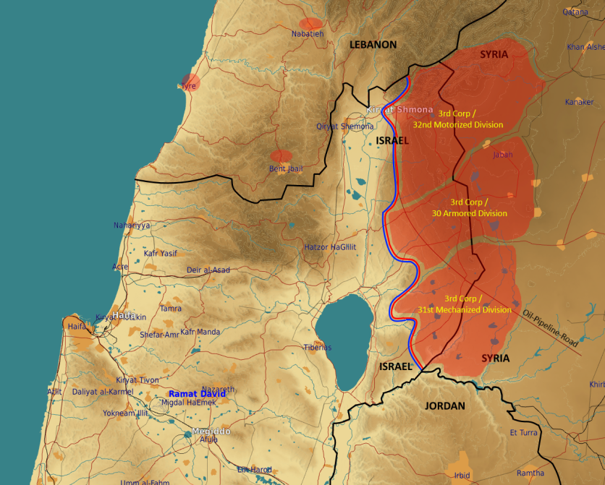

Figure : 3rd Corps positions

# General information

## Air

* As of D+0, VID have not been able to determine a pattern in CAP and QRA missions flown by Syrian forces. It is however likely that any intrusion into Syrian airspace will be faced with a reaction from Syrian Air Force.

## Sea

* 1st Patrol Boat Squadron, assessed to still be at port in Latakia

## Land

* No additional information about 4th and 5th Corps

# Information gaps

* What is the status of Syrian SCUD units?
* What is the status of Syrian Air Force
  + DCA missions? (Does the Syrian Air Force fly CAPs?
  + QRA (reaction times, from what bases type of aircrafts)
* What is the status of 4th Corps and 5th Corps (Are they leaving bases, of yes, that can indicate a major Syrian offensive. Which direction?)
* What is the status of Syrian Air Force A-G missions?
* Is there presence of Russian forces in either Tartus or Bassel Al-Assad airfield?
* What is the status of Syrian IADS?
  + Positions of EWR
  + Position of SAM sites
  + Is the entire IADS operational